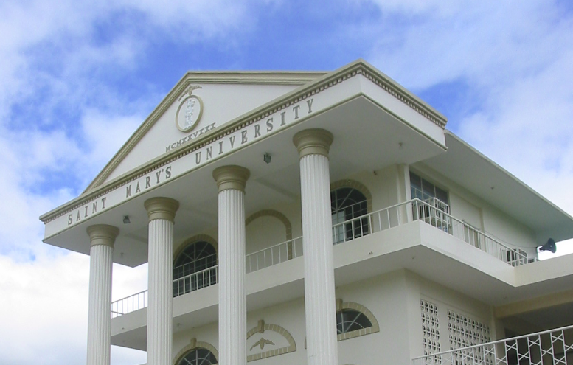

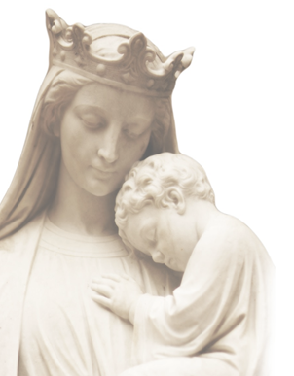

**** RC

**** URC

**${Adviser}**

Adviser

***“${Title}”***

**Saint Mary’s University**

*Bayombong, Nueva Vizcaya*

**SCHOOL OF ENGINEERING, ARCHITECTURE**

**AND INFORMATION TECHNOLOGY**

**Bachelor of Science in ${Course}**

S.Y. ${SchoolYear}

Researchers

**${Students}**